**United Spirits Limited – Research Report**

**Overview of the company:**

Alcohol is loved by majority of the people around the globe. There were hundreds of alcohol manufacturing companies across the globe and they produce alcohol under different brands. **United Spirits Limited**, abbreviated to **USL**, is an Indian alcoholic beverages company, and the world's second-largest spirits company by volume. It is a subsidiary of Diageo, and headquartered at UB Tower in Bangalore, Karnataka. USL exports its products to over 37 countries. It manufactures, sells premium liquor brands such as Johnnie Walker, Black Dog, Signature, Royal Challenge, McDowell’s No 1. These brands were even known by the rural population of India. People go crazy about these brands and this company has also established well with good customer base.

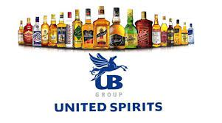

**Shareholding pattern of the company:**

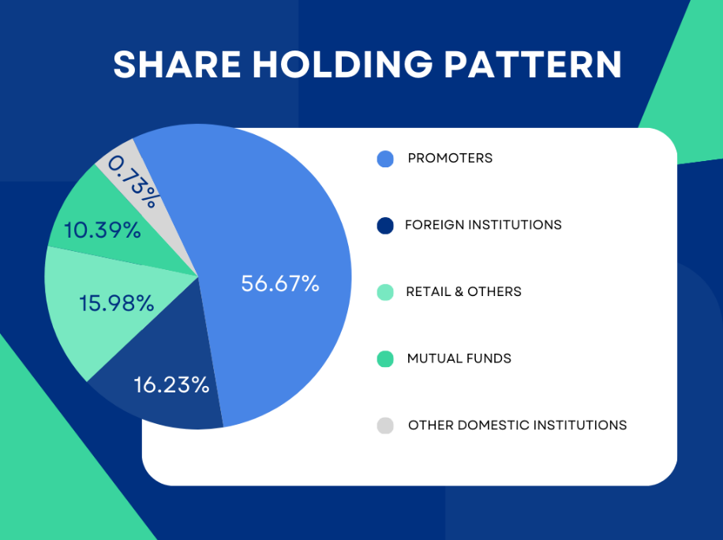

Source of the data: Groww Website data, Pie chart prepared by me in Canva**.**

United Spirits limited company’s shareholding pattern is shown in the pie diagram. The major shareholder of the company is promoters. Promoters held 56.67% share. Followed by Foreign Institutional Investors with 16.23%. Retailers & other participants held 15.98% share in the company. Mutual Funds has also held the share in the company with 10.39% share in the company. Domestic Institutions participation is very minute as they held 0.73%. Promoters and Foreign Institutions are having major share portion of the company.

**Management of the company:**

The list of the board members is as follows:

* **Mr. Mahendra kumar sharma - Chairman & Ind. Director**
* **Mr. Pradeep Jain - Executive Director**
* **Dr. Mrs. Indu Shahani – Independent Director**
* **Mr. V K Viswanathan – Independent Director**
* **Mr. D Sivanandhan- Independent Director**
* **Mr. Rajeev Gupta - Independent Director**
* **Ms. Hina Nagarajan - Managing Director & CEO**
* **Ms. Mamta Sundara - Non-Executive Director**
* **Mr. John Thomas Kennedy - Non-Executive Director**
* **Mr. Mark Dominic Sandys - Non-Executive Director**

The company is family operated; it is professionally operated. Hina Nagarajan became the Managing Director and CEO of Diageo India effective July, 2021. Earlier, she was Managing Director, Diageo - Africa Emerging Markets (AEM) since August 2018 leading business operations across Ghana, Ethiopia, Cameroon, Indian Ocean, Angola and other WACA countries. Under her leadership, AEM transformed to become a significant growth driver for Africa whilst doubling operating margins.

She is highly qualified and also capable of driving the company to the great heights. The other existing board members were also equally capable of making right decisions. In conclusion the company is having good management.

**SWOT Analysis:** 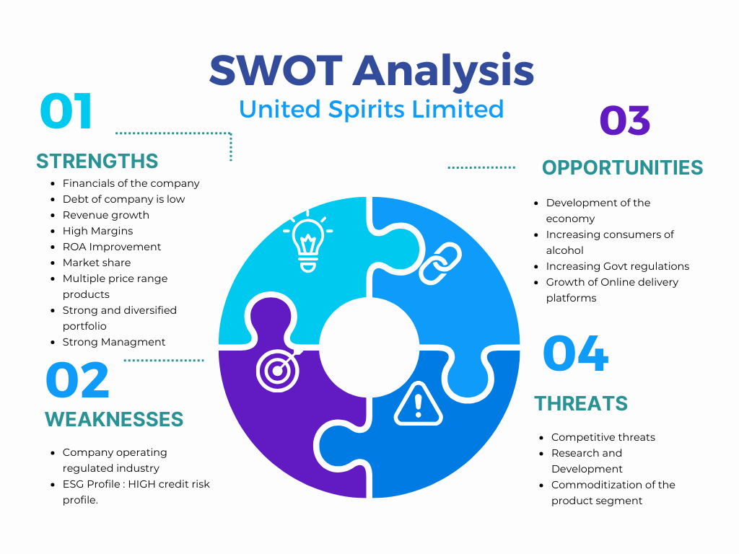

**Strengths:**

1. **Financials of the company:**

* United Spirits Net sales has been increased 150.55% which is 6962.00 Crore in De ember as compared 2022 December 2788.70 Crores.
* Quarterly Net Profit at Rs. 350.20 crore in December 2023 up 63.49% from Rs. 214.20 crore in December 2022.
* EBITDA stands at Rs. 538.60 crore in December 2023 up 37.01% from Rs. 393.10 crore in December 2022.
* United Spirits EPS has increased to Rs. 4.93 in December 2023 from Rs. 3.02 in December 2022.

1. **Debt of the Company is low:** United Spirits debt is Rs. 2.0 billion. The overall shareholder equity is Rs. 68.1 billion, which in turn equates to 3% Debt-to-equity ratio.
2. **Revenue growth:** The revenue of the company has been constantly increasing for the past 3 quarters which is a s good sign and trigger point of the company.
3. **High Margins:** The products manufactured by the company are having high margins compared to other manufacturers.
4. **Efficient in managing Assets to generate Profits - ROA improving since last 2 years.**
5. **Market Share:** United Spirits is having leadership position in the spirits industry 9n India with 25% Market Share.
6. **Strong and Diversified Portfolio:** The company has 9 brands that sells more than a million cases each year. One brand sells more than 254 million cases.
7. **Availability of products in various prices:**
8. **Strong Management:** The Parent Diageo group holds 55.94% stake in the company, which has the complete management control over the entity.

**Weakness:**

1. **Company Operating in regulated industry:**  The Alcohol industry is highly regulated by the government. Any policy or regulations taken against the company may affect the growth of the company. It needs several permissions to take or make any changes in the product.
2. **ESG Profile:** According to the sources available (CRISIL Report) the company is already rated as the strong credit risk profile. The alcohol sector has a moderate environmental impact, primarily driven by its raw material and waste intensive processes.
3. **High cost of Replacement:** The industry in which the company is operating is extremely different and difficult to operate. The experts in this field are also very few and replacing them is hard for the companies operating in this industry.

**Opportunities:**

1. **Development of the Economy:** As the India’s Economy growing at a pace of 6.2% CAGR, it will definitely help and contribute to the growth. It will provide an opportunity to expand.
2. **Increasing Consumers of Alcohol:** Majority of the Indian population specially in urban area of India, the alcohol is very high and when in weekend it is even more. People standards are developing and they are choosing parties, celebrations and the common thing is Alcohol. So the demand for the product will always stays high.
3. **Increasing Government Regulations:** It is difficult for the un-organized people to enter into the business. So, the market share will unlikely get impacted.
4. **Growth of Online delivery platforms:** The growth of online delivery platforms will eventually benefit the alcohol companies as it makes easier for the people to order online. This will drastically help the sales of the products.

**Threats:**

1. **Competitive Threats:** Alcohol is loved by many people and there were numerous brands marketed and manufactured by different companies and different price levels. So, the competition from the companies will rule out them if they did not market the product with competitive pricing.
2. **Research and Development:** Companies always should strive to bring new flavoured beverages and alcohol in order to attract and retain the customer.
3. **Commoditization of the product segment:** The biggest challenge for the companies operating in the segment is increasing commoditization of the products in Consumer industry.

**Competitive Analysis:**

United Spirits is having tough competition with its peers, United Breweries, Radico Khaitan, Sula Vineyards and other as well. Each company is competing with united spirits in one particular product.

1. **Beer segment**: **United Breweries** is the company which manufactures the world-famous beer brand named **Kingfisher. Kingfisher** is the largest selling Indian beer brand. United spirits face tough competition with united breweries in selling beers.
2. **Brandy Segment: Manion House brandy** is the most famous even in rural population villages. Mansion House is manufactured by **Tilaknagar Industries.** United spirits will face tough competition with other brandy brands as well.
3. **Wine segment:** Sula's Shiraz Cabernet is India's largest selling wine by value in FY21. Sula Vineyard is famous around the world for its quality and premium wine. In this segment it will be toughest competition for United Spirits.
4. **Whisky segment:** Though **McDowells is the largest selling whisky** brand by united spirits it equally faces competition with **Royal Stag brand owned by Pernod Ricard company.**

There are various other alcoholic segments where united spirits presents and faces competition with its peers.

**Conclusion: United Spirits** is a good company with strong fundamentals and high margins which is also low debt. This company has various famous brands in each segment of alcohol. The company will remain with highest market share for a longer period. I believe company will even grow at a CAGR higher than present growth. United spirits need to focus and develop R&D in order to release or to start new flavoured alcohol products. Acquiring the smaller companies and also by investing in the startups which were Non-alcoholic beverages will help the company to grow even larger.

**Thank You**